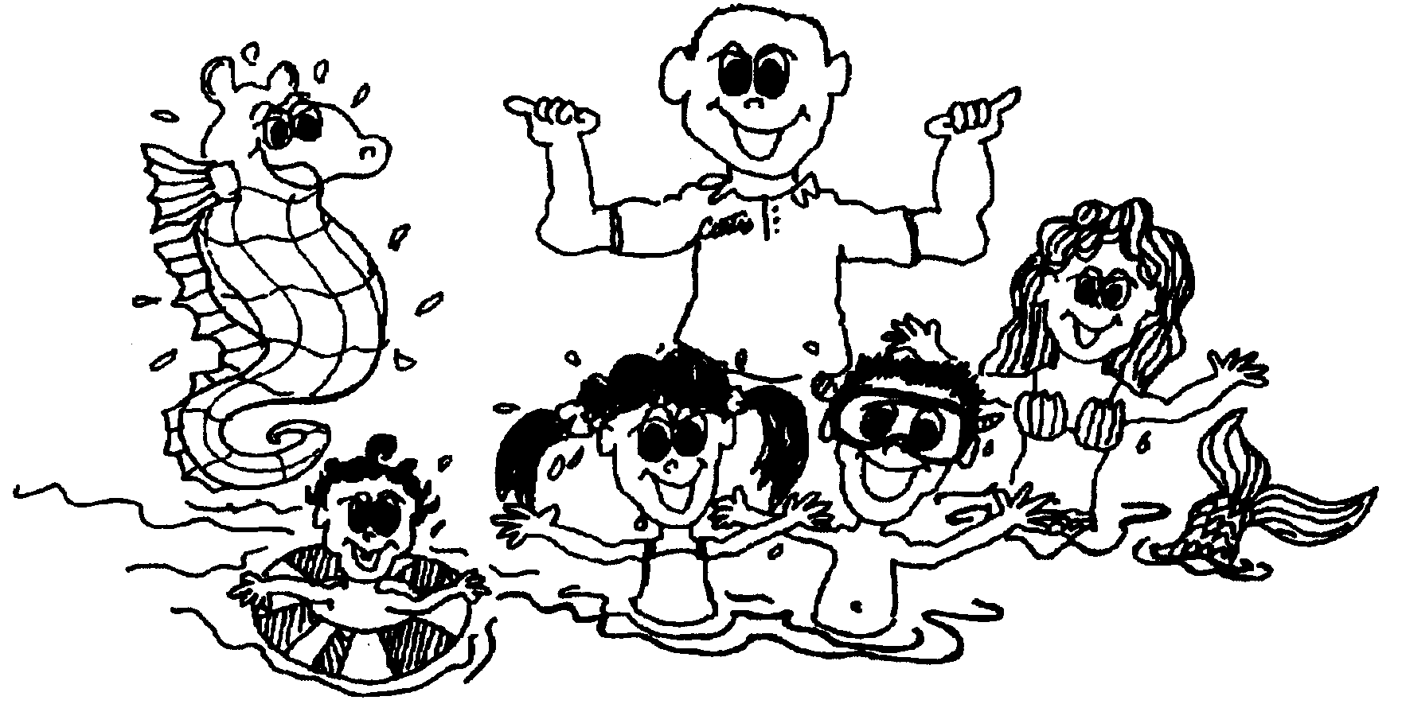

Curtis Turner, Inc. 91-440 Pupu St. Ewa Beach, HI 96706 (808) 753-5720

CONSENT FORM

Please call if you are unable to attend class. If you are sick, please DO NOT come to class. Hair should be pulled back into pony or pigtails.

There will be NO MAKE-UP LESSONS.

Participant’s Name:___________________________Age:____DOB:________Sex:____

Parent’s Name:___________________________________________________________

Home Phone:________________Cell Phone:_______________Work:_______________

Address:________________________________City:__________________Zip:_______

Email:__________________________________________________________________

Medical Info: (Allergies, Medication, etc.)_____________________________________

I hereby give participant named above permission to attend and participate in the swimming activities conducted by Curtis Turner, Inc. I hereby voluntarily release, discharge, waive and relinquish any and all action or causes of action for personal injury, property damage or wrongful death occurring as a result of engaging in said swimming activities, nor shall their, executors, administrators and assigns prosecute or present any claim against Curtis Turner, Inc. or any of his family members.
It is the intention of this document to exempt Curtis Turner, Inc. from liability for personal injury, property damage, or wrongful death cause by negligence.
I acknowledge that I am authorized and empowered to sign this agreement, that I have fully read and understand the foregoing statements and am fully aware of the legal consequences of signing this document.

I also, (agree) (disagree) to have my child or myself photographed while in class. I understand that these pictures (still and video) may be used in advertising.

PARENT/GUARDIAN OR
PARTICIPANT’S SIGNATURE:_______________________________DATE:______

Curtis Turner, Inc. 91-440 Pupu St. Ewa Beach, HI 96706 (808) 753-5720

SWIMMING RECEIPT
TOTAL $_______

